1. Helm Chart Architecture?
2. Helm Chart CLI ?
3. First **“Hello World ”** Helm Chart

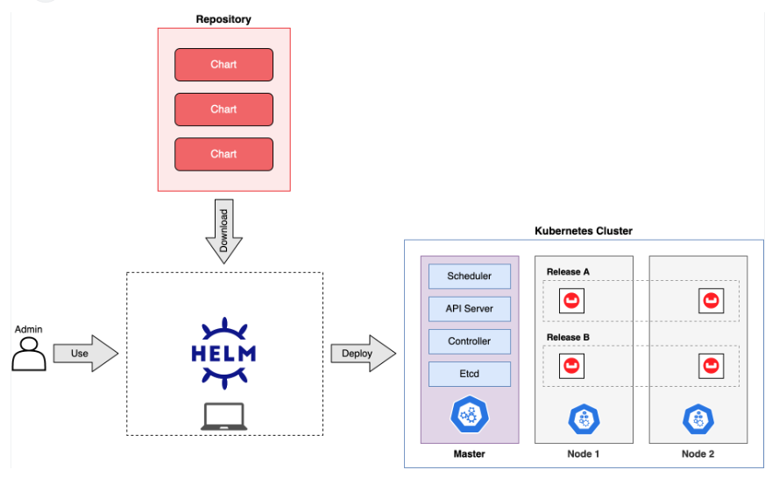

helm create helloworld

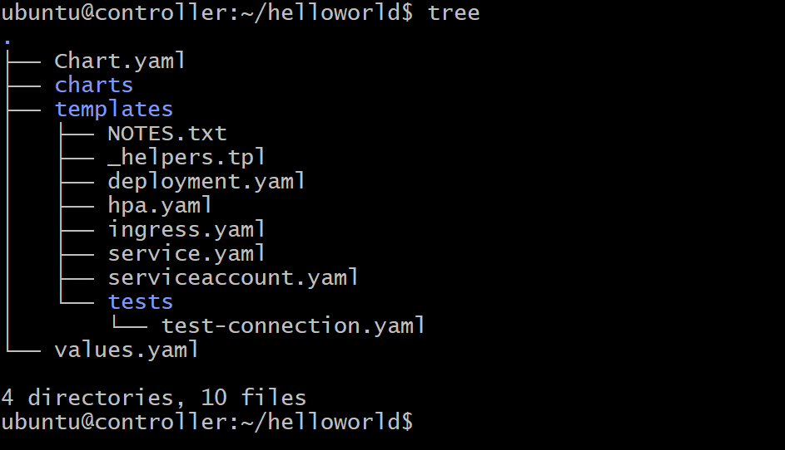

Vi values.yaml

Change service.type = NodePort

helm install myhello_deployment helloworld

Or

microk8s helm3 install myhello-deploy helloworld/

microk8s dashboard-proxy

change http to https

https://3.84.4.150:10443/

**Login token**

